CPD for SEND
Priority: Read section 6 of the Code of Practice. (It would be really amazing if everyone could do this!)
https://assets.publishing.service.gov.uk/government/uploads/system/uploads/attachment_data/file/398815/SEND_Code_of_Practice_January_2015.pdf

Then the choice is yours!! (Some hints: If you work in Treen, then the Nasen early years course would be good, and also the attachment in the early years Open Edu (Open University) Course. If you haven’t done any TiS/Thrive training then the ACE’s course may be worth looking at. Other than that please study in areas that you have interest/need in your class.
If you are interested in a certain area and I haven’t included it, then please let me know and I will find the best study material on line for that area.
ASD/ADHD
Free online CPD course through Derby Uni on ASD and ADHD (looks good).  This short online course will encourage you to challenge your own definitions and perceptions of autism and ADHD. You will get an opportunity to examine several key themes around both autism and ADHD in order to obtain skills to help people with these conditions. | https://www.derby.ac.uk/short-courses-cpd/online/free-courses/understanding-autism-aspergers-and-adhd/
ADHD Top tips for understanding ADHD and supporting in the classroom | https://www.sendgateway.org.uk/r/top-tips-for-understanding-adhd-and-supporting-children-in-the-classroom.html
Speech and Language
Communication Trust  Focuses on children and young people’s speech, language and communication development. It looks at how you can support the development of these skills on a day-to-day basis in your setting, and how to spot children and young people who might be struggling to develop these important skills. | https://www.thecommunicationtrust.org.uk/projects/professional-development/online-short-course/
Dyslexia
Understanding Dyslexia Making Sense of Dyslexia  - Introduction to Dyslexia and Inclusive Practice  - Supporting Dyslexia, inclusive practice and literacy  - Identification and support | http://addressingdyslexia.org/free-online-learning-modules
Supporting children with difficulties in reading and writing | https://www.coursera.org/learn/dyslexia-difficulties/
Inclusive Education
Essential Knowledge for Success  Discover what inclusive education really is, explore its benefits and learn to implement it at system, school and classroom level. |  | https://www.futurelearn.com/courses/inclusive-education
Education for All: Disability, Diversity and Inclusion  Discover ways to make education more inclusive, especially in areas where resources are limited. |  | https://www.futurelearn.com/courses/education-for-all

Access to Education offer lots of free online CPD course on a range of subjects (see below). You need to sign up free for an account but once signed up courses are available. These are well worth looking at.
http://vle.pupilschoolsupport.org/login/index.php?fbclid=IwAR1wSb1oCFVnehyERib4GFc1MaHB-85ijcndR1cW8kxrGwr6HwEQnhijq6M
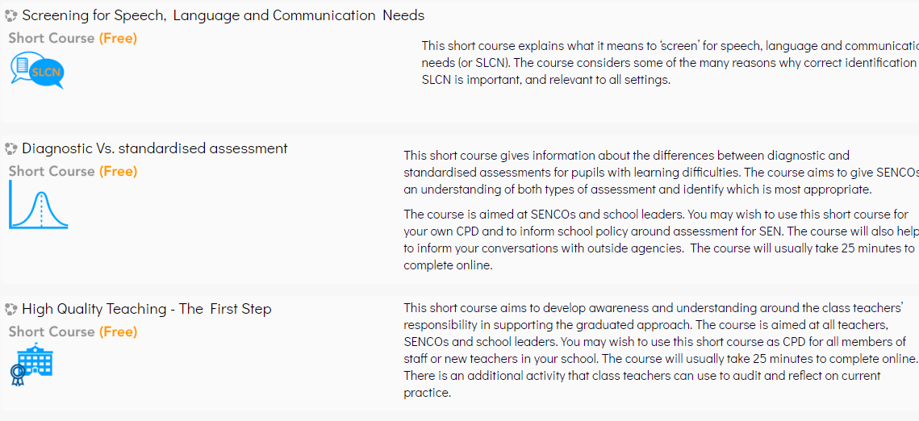
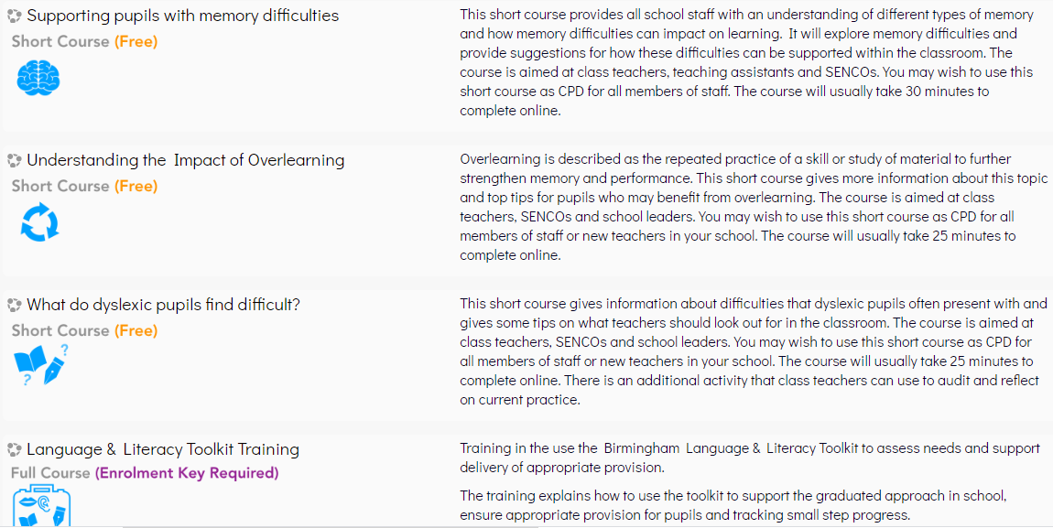

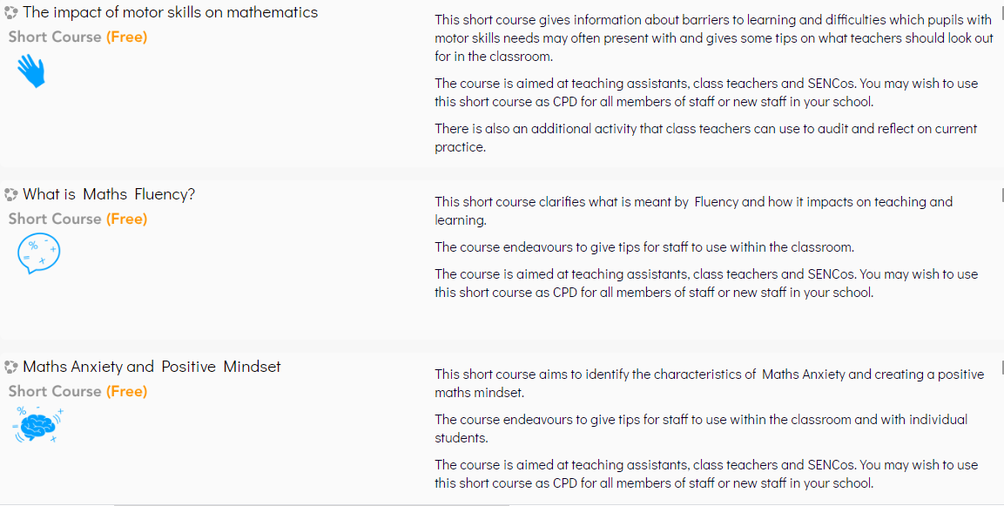
Nasen (National Association for Special Educational Needs):
You will need to register for these courses (free) but they are well recognised and worth doing:
https://nasen.org.uk/training-and-cpd/online-learning.html
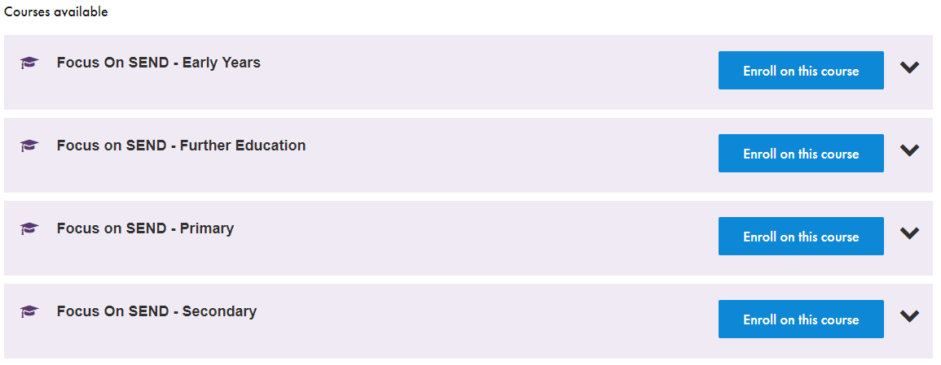

Free online course on ACE’s (Adverse Childhood Experiences) For those that haven’t done Thrive of TiS training:
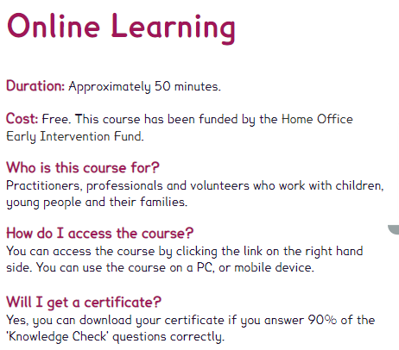https://www.acesonlinelearning.com/?fbclid=IwAR2M7YaKyQrvx6ujnzAkSZnFZ8OEnjNiSlJHy9UUxZ-sBFN-G_PHLlKq9XA

Teaching Students Who Have Suffered Complex Trauma
Find out what complex trauma is, how it affects children and adolescents, and what can be done to help.
https://www.futurelearn.com/courses/education-for-all

Attachment in the early years
Covers theory and research in the area of attachment in early childhood.
https://www.open.edu/openlearn/education-development/early-years/attachment-the-early-years/content-section-0?active-tab=description-tab

