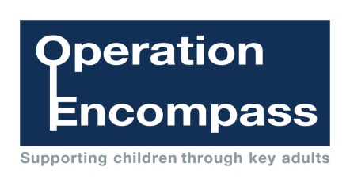

Mrs Rogers and Mrs Thomas are the Key Adults at St Erth School.

For further information, please visit the Operation Encompass website at

www.operationencompass.org



**Caring, Sharing, Preparing for Life**

In every force, in every school, for every child

Operation Encompass is the early reporting on to schools that a child or young person has been exposed to domestic abuse